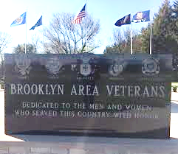
Brooklyn Area Veterans Memorial, Inc.
P. O. Box 272 Brooklyn, WI 53521

http://brooklynveteransmemorial.org
www.facebook.com/Brooklyn-Area-Veterans-Memorial 614578461963737
Engraving Name on the Wall

Purchaser____________________________________________________Date_____________________
Address______________________________________________________________________________
City__________________________________________ State_____ Zip Code______________________
Phone____________________ Email address________________________________________________
Veterans may have their names engraved on the wall at Brooklyn Area Veterans Memorial if the veteran entered into military service from the Brooklyn, WI Area or lived in the Brooklyn, WI Area for at least 5 years. Veterans will need to provide a copy of their DD Form 214/215 or NGB 22/22A as proof of veteran status.*
Cost: $150/per name There is no longer space available under the Korean War.
ALL REQUESTS are completed annually and must arrive by May 1 to be completed by Memorial Day.

Veterans Name (Print legible): ____________________________________
Veterans Years of Service (Print legible):_____________________________
Veterans Campaign/War (Print legible):_____________________________

I confirm that the information given on this form is complete and accurate.

Purchaser Signature______________________________________Date______________________
Please mail a check, proof of veteran status, and completed order form to:
Brooklyn Area Veterans Memorial Council, Inc. P.O. Box 272, Brooklyn, WI 53521.

*DD Forms 214/215 are for those who served in the reserve and on active duty. NGB forms 22/22A, Report of Separation and Military Service, for those who served in the Army and Air National Guard.

